**PROJECT REPORT**

**Meenakshi Nagarajan**

**HUMAN FACTORS IN WEB DESIGN**

**CONTENTS**

|  |  |  |
| --- | --- | --- |
| S. No. | TITLE | Pg. No. |
| 1 | Abstract | 3 |
| 2 | Introduction | 3 |
|  | **2.1** Overview | 3 |
|  | **2.2** Literature Review | 4 |
|  | **2.3** Product System Description | 4 |
|  | **2.4** Problem Statement | 5 |
| 3 | Analysis #1 | 6 |
|  | **3.1** GOMS Method of Analysis | 6 |
|  | **3.2** Description of findings | 8 |
| 4 | Analysis #2 | 9 |
|  | **4.1** Classification of system users | 9 |
|  | **4.2** Sources of data | 9 |
|  | **4.3** KLM- GOMS Method of analysis | 10 |
|  | **4.4** Description of findings | 12 |
| 5 | Analysis #3 | 13 |
|  | **5.1** SWOT | 13 |
| 6 | Results | 14 |
|  | **6.1** Design Recommendation | 14 |
|  | **6.2** Description | 15 |
| 7 | **Conclusion** | 17 |
| 8 | **References** | 18 |

**1. ABSTRACT**

Websites are widely used in daily life of every individual for variety of purpose such as accessing E-mails, online banking, online shopping, social networking etc. With the rise in the use of websites, it is critical that every organization must have a strong web presence. Usability and safety are the two most important aspects that has to be taken into account while designing a website. This project deals about how the application of human factors concepts helps in the process of developing an efficient website.

Few aspects that has to be taken into account while designing a user interface includes response time, universal design, security, working memory etc. with proper feedback and alerts at appropriate places. Lack of any of these features result in a poor user experience.

This project involves analyzing the entire [www.wright.edu](http://www.wright.edu) and provide design recommendations that makes it highly usable and that suits for all types of users.

**2. INTRODUCTION**

**2.1 Overview**

Human-computer interaction (HCI), is all about the way in which people interact with computer systems. HCI approach to web design is critical, as it involves all aspects of interaction - physical, perceptual, cognitive, social. This project, examines the design of a website and provides solution for these aspects of interaction, if they do not meet a satisfactory level.

Physicals aspects

* Devices touched by user, manuals, documentation, and forms

Perceptual aspects

* Everything else user sees, hears, or touches such as screen objects, menus, and buttons

Conceptual aspects

* What user knows about system and logical function of system

The web has revolutionized how people access information. As web has become an important source of information for all of us, the significance of presenting that information in a way that people can quickly and easily use it should be obvious. One of the key human factors issues surrounding the presentation of information on the web is page layout. Our aim is to adopt a proper layout to the page thus making it responsive. Also, web has become more critical these days. People check the same site frequently (e.g., checking email, bill payments, etc.). So it is high time to automate the repetitive and complex tasks and thus reduce mental and physical stress to the users.

**2.2 Literature Review**

One of the often debated issues in page deign for the web is whether to use a fixed layout or fluid layout. Fixed layout does not change with the size of browser window whereas the fluid layout adapts itself to the size of the browser window. Although no differences were found in terms of loading speed and other features, fluid layout is preferred because it adjusts to the user’s screen solution.

Proctor, R. (2005). *Handbook of human factors in Web design*. Mahwah, N.J.: L. Erlbaum Associates. Presentation of Information: Page Layout. Fixed versus Fluid Layout, 159-160.

Bernard and Larsen studied three different approaches to the layout of multicolumn webpages: fluid, fixed centered, and fixed-left-justified. They also used two different window sizes: large (1006 pixels wide) and small (770 pixels wide). They found no significant differences in terms of accuracy or speed with which users found the answers to questions. However, the fluid layout got significantly higher subjective ratings than either of the two. Overall, 65% of the participants selected the fluid layout as their top choice. This is consistent with the recommendation of Nielsen and Tahir (2001, 23) to use a fluid layout because it adjusts to the users’ screen resolution.

**2.3 Product System Description**

The system we deal with is website. A website is a set of related webpages, written in plain text interspersed with formatting instructions of Hypertext Markup Language. Websites are highly important for any organization to increase its visibility. Human factors approach in designing a website is important to make it a successful one.

Websites should be designed in such a way that it meets all the aspects of interaction. Some common issues surrounding the presentation of information on the web are: Page layout, Navigation, Links, Texts and fonts, Graphics and multimedia, Tables and graphs, Color, Types of pages etc. The layout of information on a computer screen or any other device clearly has a significant impact on its usability.

With the advent of mobile phones and tablets, websites are accessed from several devices with different resolutions. It is important for a website to change their according to the device. This way it can be made responsive and the user interaction can be made simple and efficient

One of the major characteristics of a good user interface is that it should be able to support multiple skill levels (from novice to expert) and also it should have high usability. Although the website has met these demands, it should still be examined to bring out an alternative solution to achieve the goal to a satisfactory standard.

**2.4 Problem statement**

The website we have analyzed is <http://www.wright.edu> . One of the key problems associated with this site is its inability to change its resolution, image size etc. when the page is resized. When we tried accessing the website through a mobile, we could see that the the elements of the layout are rearranged. From this we found that, a separate codebase has been written for each device. Our aim is to write a single code to design a user interface and using the same across devices.

This way we hope to build a responsive website which can alter its layout based on screen size, platform and orientation without the need to write a device specific code.

Below is the image of a page that is responsive.

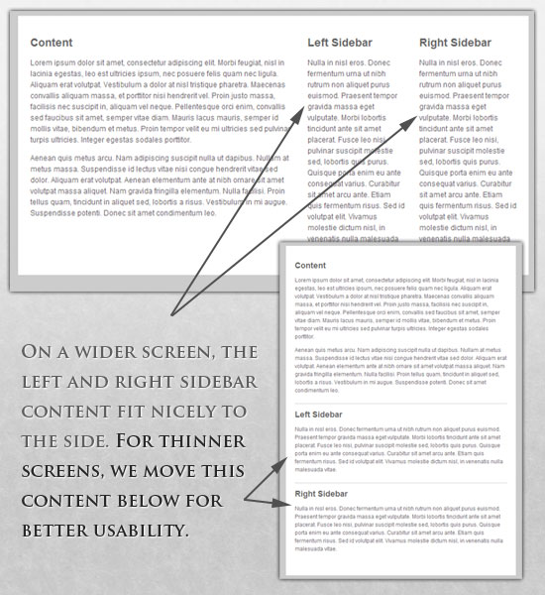

**Fig 2.1 Example of a Responsive Webpage**

Also, in any web application, humans always find it difficult to perform the following tasks:

* **Finding the right web pages in case of nested webpages and links.**
* **Providing right inputs (Username and passwords).**
* **Form filling (Sign up forms).**
* **Following the guidelines to complete a task.**

All these tasks involve both motor and cognitive abilities. Frequent users know the exact location of webpages as a result of which their mental workload will not be high whereas their motor skills will be required as they have to navigate through pages. Occasional users will have to input both motor and cognitive skills in order to reach the goal. Our aim is to minimize both the mental and physical workload. This can be achieved by introducing the concept of macros which helps in recording the tasks and replaying it and thus automating the repetitive tasks.

**3. ANALYSIS #1**

**3.1 GOMS (Goals, Operator, Methods, Selection) Method of Analysis**

Below is the sequence of steps followed to open a webpage.

GOAL OPEN-WEBPAGE-AND-LOGIN

GOAL OPEN-WEBPAGE

Operator SELECT-BROWSER-WITH-MOUSE

Operator DOUBLE-CLICK-MOUSE-BUTTON

Operator MOVE-CURSOR

Operator TYPE-WEB-ADDRESS

Select*:

GOAL USE-MOUSE

Operator PRESS-LOAD-ICON-ON-SCREEN

GOAL USE-KEYBOARD

Operator PRESS-ENTER-BUTTON

GOAL LOGIN

Operator MOVE-THE-CURSOR-TO-LOGIN-BUTTON

Operator CLICK-ON-LOGIN-BUTTON

Selection rule for GOAL OPEN-WEBPAGE*

**if** HANDS-ARE-ON-KEYBOARD **then**

select **GOAL** USE-KEYBOARD

**else**

select **GOAL** USE-MOUSE

Once opened, the page size has been changed and the analysis has been done to login.

GOAL RESIZE-WEBPAGE-AND-LOGIN

GOAL RESIZE-WEBPAGE

Operator MOVE-CURSOR-TO-PAGE-BORDER

Operator PRESS-AND-HOLD-MOUSE

Operator DRAG-AND-RESIZE-SCREEN.

GOAL-LOGIN

**Operator PRESS-AND-HOLD-MOUSE**

**Operator SCROLL-THE-SCREEN-TO-RIGHT**

Operator MOVE-THE-CURSOR-TO-LOGIN-BUTTON

Operator CLICK-ON-LOGIN-BUTTON

From the above analysis, it has been found that the two additional steps are required to achieve the goal of login. Since, the login button is on the top right corner of the webpage the screen requires scrolling after resizing. Thus it has been discovered that the page is not responsive.

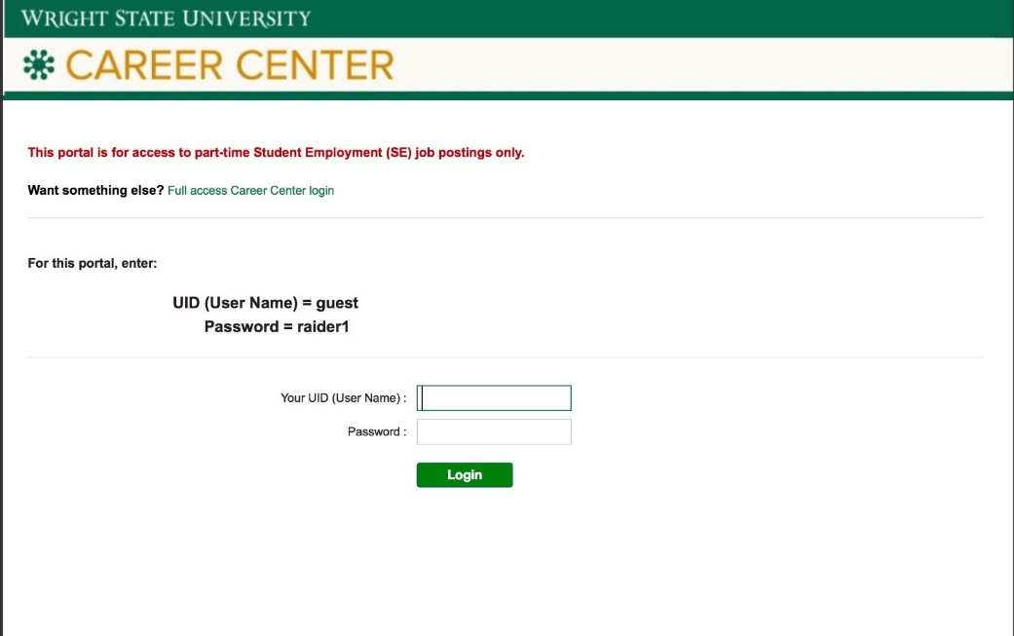

**Fig 3.1** **Webpage before resizing**

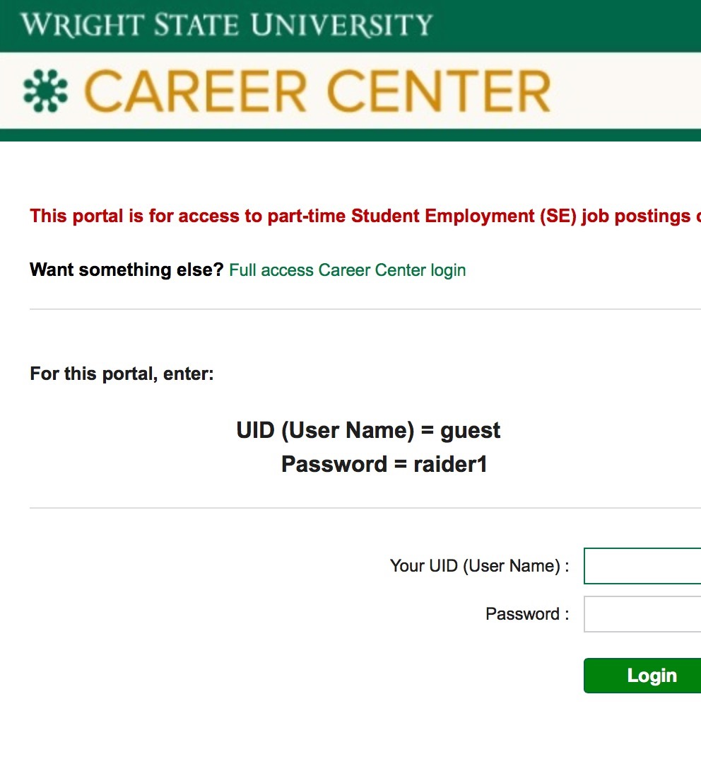

**Fig 3.2** **Webpage after resizing**

**3.2 Description of findings**

From the above analysis, we have found that the page does not alter its layout while resizing.

* This cause the user to scroll back and forth to view the information. This makes it difficult for the users to keep their place on a line and scan chunks of information.
* Horizontal scrolling, or the necessity to scroll horizontally to view all the information on a webpage is strongly disliked by almost all web users and should be avoided.
* Its also been found that users can reach their desired target items significantly faster if the content is present on a single page.
* This leads to a visually complex page which results in more variability in users’ scan paths.

These findings suggest that a webpage should be responsive which could possibly help users scan the items and reach their target place quickly.

Also, a good website is the one that is compatible with all the devices that are used to access the website.

The solution that we are going to provide makes it flexible and compatible with all the devices that are used to access the site without producing a device specific code. The principle followed is write once use everywhere.

The code written in Java server pages with a CSS style sheet incorporated. Changing the existing CSS style sheet with the addition of JavaScript can accommodate far more variations resulting in a responsive web design.

**4. ANALYSIS #2**

The website we worked on is [www.wings.wright.edu](http://www.wings.wright.edu). The goal is to login to the wings account. This has been tested with three different users: expert, novice and aged users.

**4.1 Classification of system users**

**Novice:**

* Rely on guidelines to use the site.
* Require both mental and physical effort.

**Expert:**

* Knows the location of the webpages.
* Saves time in reaching the target as no mental effort is required.
* Requires physical effort in reaching the target.

**Aged Users/users with disability:**

* Have difficulty in remembering the passwords.
* Have difficulty in following the guidelines.

So our aim is to address various issues concerned with these users by saving time in achieving the goal, providing memory aids and help in assisting the new users by providing visual guidelines in using the site. This way we hope to build a site with high usability.

**4.2 Sources of data**

We conducted a passive observation of users who logs in their account. This way we identified the sequence of steps involved while logging into their account and the time associated with it. Later, these steps are reduced to a deeper level to find the different operators involved.

Also, through active observation we found the frequency of use of the site among the users and

the tedious tasks involved in using the site.

**4.3 KLM - GOMS Method of Analysis**

We are analyzing simple task of login wings account and open one’s email page through GOMS method and measuring the time associated with each task for various users

**GOAL** LOGIN-TO-WINGS-ACCOUNT-AND-OPEN-OFFICE 365/EMAIL

GOAL OPEN-WEBPAGE

Operator SELECT-BROWSER-WITH-MOUSE

Operator CLICK-MOUSE-BUTTON

Operator MOVE-CURSOR

Operator TYPE-WEB-ADDRESS (www.wings.wright.edu)

Select*:

GOAL USE-MOUSE

Operator PRESS-LOAD-ICON-ON-SCREEN

GOAL USE-KEYBOARD

Operator PRESS-ENTER-BUTTON

GOAL LOGIN

Operator MOVE-THE-CURSOR-TO-USERNAME-FIELD

Operator TYPE-USERNAME

Operator MOVE-THE-CURSOR-TO-PASSWORD-FIELD

Operator TYPE-PASSWORD

Operator MOVE-THE-CURSOR-TO-LOGIN-BUTTON

Operator CLICK-ON-LOGIN-BUTTON

GOAL OPEN OFFICE 365/EMAIL

Operator MOVE-THE-CUSOR

Operator CLICK-ON-OFFICE 365/EMAIL

Selection rule for GOAL OPEN-WEBPAGE*

**if** HANDS-ARE-ON-KEYBOARD **then**

select **GOAL** USE-KEYBOARD

**else**

select **GOAL** USE-MOUSE

**TABLE 4.1: Time associated with each task for different users:**

|  |  |  |  |  |
| --- | --- | --- | --- | --- |
| **GOAL:**  **OPEN**  **WEBPAGE** | **Operators** | **Time t (sec)** | | |
| **Expert** | **Novice** | **Other users** |
| SELECT-BROWSER-WITH-MOUSE | 0.8 (P) | 1.10 (P) | 1.5 (P) |
| CLICK-MOUSE-BUTTON | 0.20 (K) | 0.20 (K) | 0.40 (K) |
| MOVE-CURSOR | 1.10 (P) | 1.10 (P) | 1.5 (P) |
|  |
| TYPE-WEB-ADDRESS | 2.8 (KH) | 6 (KH) | 24.4 (KH) |
| PRESS-LOAD-ICON-ON-SCREEN / PRESS-ENTER-BUTTON | 0.20 (K) | 0.20 (K) | 0.40 (K) |
| **GOAL:**  **LOGIN** | MOVE-THE-CURSOR-TO-USERNAME-FIELD | 1.5 (PH) | 2.85 (MPH) | 3.25 (MPH) |
| TYPE-USERNAME | 2.31 (KMH) | 3.71 (KMH) | 10.15 (KMH) |
| MOVE-THE-CURSOR-TO-PASSWORD-FIELD | 1.5 (PH) | 2.85 (MPH) | 3.25 (MPH) |
| TYPE-PASSWORD | 2.71 (KMH) | 5.11 (KMH) | 16.15 (KMH) |
| MOVE-THE-CURSOR-TO-LOGIN-BUTTON | 1.5 (PH) | 2.85 (MPH) | 3.25 (MPH) |
| CLICK-ON-LOGIN-BUTTON | 0.20 (K) | 0.20 (K) | 0.40 (K) |
| **GOAL:**  **OPEN OFFICE 365/EMAIL** | MOVE-THE-CUSOR | 1.10 (P) | 2.45 (MP) | 2.85 (MP) |
| CLICK-ON-OFFICE 365/EMAIL | 0.20 (K) | 0.20 (K) | 0.40 (K) |
|  | **PREDICTED TIME** | **15.72** | **28.82** | **67.9** |

**K** - keystroke or button press (Press key or button – 0.20s, Fast typist – 0.08 s/char, average typist – 0.28 s/char, slow typist – 1.2 s/char)

**P -** pointing to a target on a display with a mouse ( 1.10s)

**M** - mentally preparing for executing physical actions (1.35s)

**H** - homing the hand(s) on the keyboard or other device (0.40s)

**Assumptions in measuring the time taken by users for each task**

1. Novice – average typist
2. Expert – good typist
3. Average length of password – 12
4. Other users take twice the time of normal users for a keystroke or button press

Based on the above table, we could see that different users takes different time to perform a task. Although experts can complete the task in fewer than 14 seconds, it could still be optimized. With respect to the novice users, they spend additional time in identifying the fields while doing the task. So we should aim to minimize the cognitive workload of novice users. Other users (aged/users with disability) takes longer time for both mental and physical activity and as a result they consume thrice the time of a novice user.

**4.4 Description of Findings**

There are several tasks that will be performed frequently. Advantages of automating these tasks are as follows:

* Minimize cognitive and motor workload
* Minimize the time taken to reach the goal
* Can be used as an alternative for guidelines that assist new users.
* Allows multi-threading, as you can do the other tasks in parallel while the macros run in the background.

There are tasks which require lot of time and assistance. For example, adding/dropping classes in wings might be difficult for new users. Here macros can be used as a tutor, which assists the users by replaying the sequence of steps.

Some tasks might result in rejection due to improper information. For example, to find part time student employment positions in wings. In http://www.wright.edu/career-center , there is a tab called Search for Jobs and a tab called Student Resources. If the user is new, then there are chances that he/she can be misled to a different page. Also, the path involved in reaching the SE postings is quite lengthy as a result of which even the frequent users might find it difficult to remember the path followed to reach the destination. In these cases, macros are very helpful. If the events are recorded during the first time, then the same can be replayed anytime the user wants to reach the page.

To use the wings account, users are expected to login every time with their username and password. This site will be used almost everyday by all the students, so it is common that the students expects a faster interaction. People might feel some difficulty in remembering the username and password or in some cases they might also feel that entering username and password frequently is tedious. Macros help overcome these issues by automating the tasks, form filling etc.,

**5.ANALYSIS #3**

**5.1 SWOT**

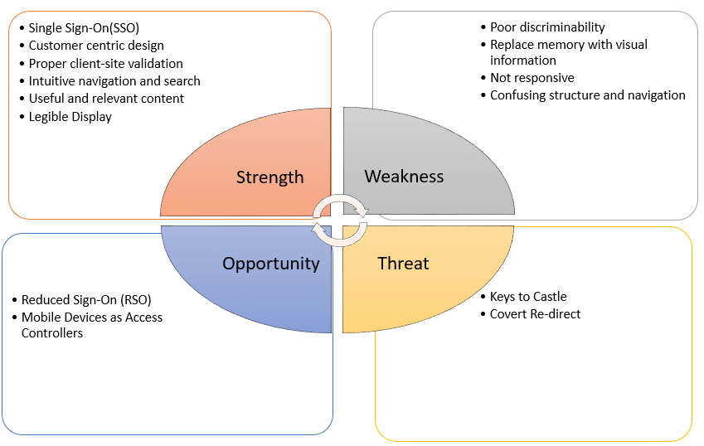

**Fig 5.1 SWOT Diagram**

**5.1.1 Strength**

It is always good to have single user name and password for all different kind of activity authentication in one organizational online service that is known as single sign-on (SSO). Customer-centric website design involves creating a commercial website that meets the wants and needs of a business's customers and prospects. An effective customer-centric design process requires the creator to put herself in the customer's place to develop a site that is user-friendly. Client Side Validation you can provide a better user experience by responding quickly at the browser level. When you perform a Client Side Validation, all the user inputs validated in the user's browser itself. Intuitive design means that when a user sees it, they know exactly what to do. A webpages should contain Useful and relevant content. Ensure legibility: Make sure the typeface you choose is legible for all intended uses.

**5.1.2 Weakness**

A poor discriminability make user confuse in comparing the objects on the webpages. Due to this it will takes longer time and more cognitive workloads. By replacing the memory to visual information makes the user easier to do a task on the websites and again to cognitive workload will be reduced. A bad webpage programming make the website not responsive. The structure of content and navigation system in the websites from one page to another should be arranged in proper order such that it will user friendly.

**5.1.3 Opportunity**

A good web design should have a good security so that it can reduce sign on for every page or content access in the website. As the mobile devices are the most commonly using the devices the web sites should be able to open on mobile devices.

**5.1.4 Threat**

If the website is unsecure there is a threat of accessing the information remotely through hacking process and even one can observe what user is doing that is keys to castle.

**6.RESULTS**

**6.1 Design Recommendations**

**6.1.1 Threats**

* Open ID Connect (OIDC)
* One Time Password (OTP)

**6.1.2 Weakness**

* Responsive web design
* Pop up on mouse over
* Macro

**6.2 Description**

**6.2.1 Open ID Connect**

Open ID Connect allows users of all types, including Web-based, mobile, and JavaScript clients, to request and receive information about authenticated sessions and end-users. The specification suite is extensible, allowing participants to use optional features such as encryption of identity data, discovery of Open ID Providers, and session management, when it makes sense for them.

**6.2.2 One Time Password (OTP)**

One time password makes the user information more secure even though user logs in with correct user and password.

**6.2.3 Responsive Web Design**

Responsive Web design is the approach that suggests that design and development should respond to the user’s behavior and environment based on screen size, platform and orientation. The practice consists of a mix of flexible grids and layouts, images and an intelligent use of CSS media queries. As the user switches from their laptop to iPad, the website should automatically switch to accommodate for resolution, image size and scripting abilities. This would eliminate the need for a different design and development phase for each new gadget on the market.

* + 1. **Advantages of Responsive Web Design**
* A responsive webpage could possibly help users scan the items and reach their target quickly.
* A good website is the one that is compatible with all the devices that are used to access the website.
* This responsive web design makes the website flexible and compatible with all the devices without producing device specific code.
* The principle followed is write once use everywhere.

**6.2.5 Analysis after implementing Macros**

**GOAL** LOGIN-TO-WINGS-ACCOUNT-AND-OPEN-OFFICE 365/EMAIL

Operator SELECT-BROWSER-WITH-MOUSE

Operator CLICK-MOUSE-BUTTON

Operator CLICK-ON-THE-MACRO-IN-THE-BROWSER

If the event has been recorded using a macro for the first time, then the same can be replayed every other time it’s used. Log in tasks are repetitive and thus it can be automated using macro.

**TABLE 6.1 Time analysis after implementation of macro**

|  |  |  |  |  |
| --- | --- | --- | --- | --- |
| **GOAL:**  **LOGIN-TO-WINGS-ACCOUNT-AND-OPEN-OFFICE 365/EMAIL** | **Operators** | **Time t (sec)** | | |
| **Expert** | **Novice** | **Other users** |
| SELECT-BROWSER-WITH-MOUSE | 0.8 (P) | 1.10 (P) | 1.5 (P) |
| CLICK-MOUSE-BUTTON | 0.20 (K) | 0.20 (K) | 0.40 (K) |
| CLICK-ON-THE-MACRO-IN-THE-BROWSER | 0.20 (K) | 0.20 (K) | 0.40 (K) |
|  | **PREDICTED TIME** | **1.2** | **1.5** | **2.3** |

By implementing macro, the time consumption for executing the entire task has been reduced by a huge amount. From this table, it is seen that no additional time has been spent on mentally preparing for initiating a task or any other activity that require mental skills. Also, the goal can be reached in just few clicks of your mouse as a result of which the time spent on physical activity is also considerably reduced.

Thus by automating the repetitive tasks, both physical and cognitive workload has been reduced.

**6.2.6 MACRO program used**

URL GOTO=https://wings.wright.edu/

SET !ENCRYPTION NO

TAG POS=1 TYPE=INPUT:TEXT FORM=ID:fm1 ATTR=ID:username CONTENT=w069mxn

SET !ENCRYPTION NO

TAG POS=1 TYPE=INPUT:PASSWORD FORM=ID:fm1 ATTR=ID:password CONTENT=xxxxxxxxxx

TAG POS=1 TYPE=INPUT:SUBMIT FORM=ID:fm1 ATTR=NAME:submit

TAG POS=1 TYPE=SPAN ATTR=TXT:Office<SP>365/Email

TAB T=2

The same macro can be customized so that multiple links can be opened other than the Office 365/Email.

**6.2.7 Advantages of Macro**

* Minimize cognitive and motor workload
* Minimize the time taken to reach the goal
* Can be used as an alternative for guidelines that assist new users.
* Allows multi-threading, as you can do the other tasks in parallel while the macros run in the background.

**7. Conclusion**

* Like other fields, such as, aviation design, training and operations, human factors research are applicable to issues in wed design.
* The goal of human factors approach in web development is to develop a site that is user friendly and highly accessible.
* This approach helps in achieving a perfect balance between all the characteristics of a good user interface.

**8. References**

1. Proctor, R. (2005). Handbook of human factors in Web design. Mahwah, N.J.: L. Erlbaum Associates.
2. John, Bonnie and Kieras, David E., The GOMS Family of User Interface Analysis Techniques: Comparison and Contrast, ACM Transactions on Computer-Human Interaction 3,4 (December 1996b), 320-351.
3. Card, Stuart, Morn, Thomas P., and Newell, Allen, The keystroke-level model for user performance with interactive systems, Communications of the ACM, 23 (1980), 396-210.
4. Kieras, David, Towards a practical GOMS model methodology for user interface design. In Helander, Martin (Editor), Handbook of Human-Computer Interaction, Elsevier Science Publishers, Amsterdam, The Netherlands (1988),135-137.